# **Advanced Optimization**

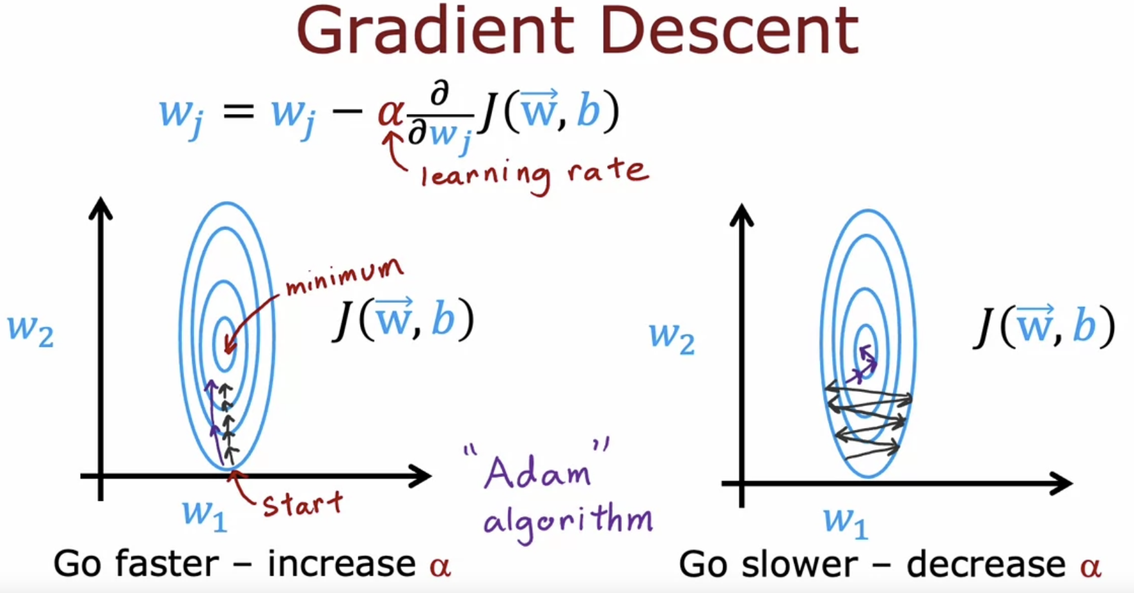

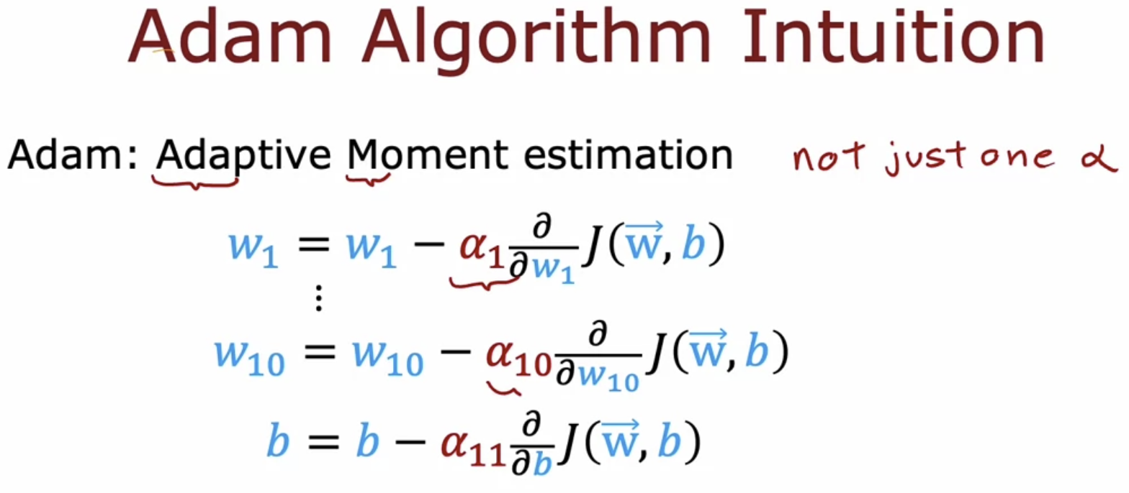

In Gradient Descent, there will be only one fixed learning rate.  
But in Adam according to parameters the learning rate can be changed.

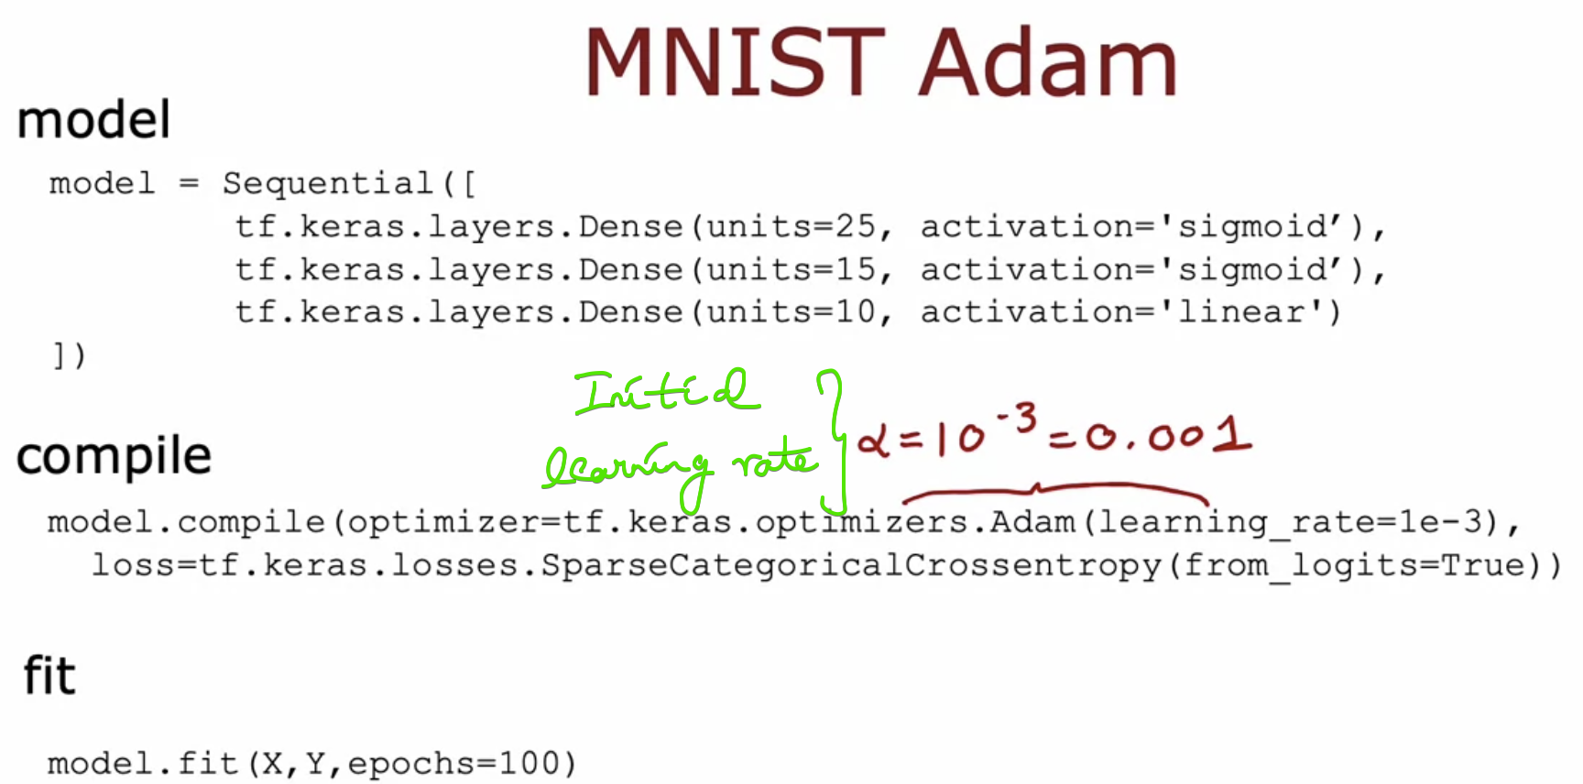

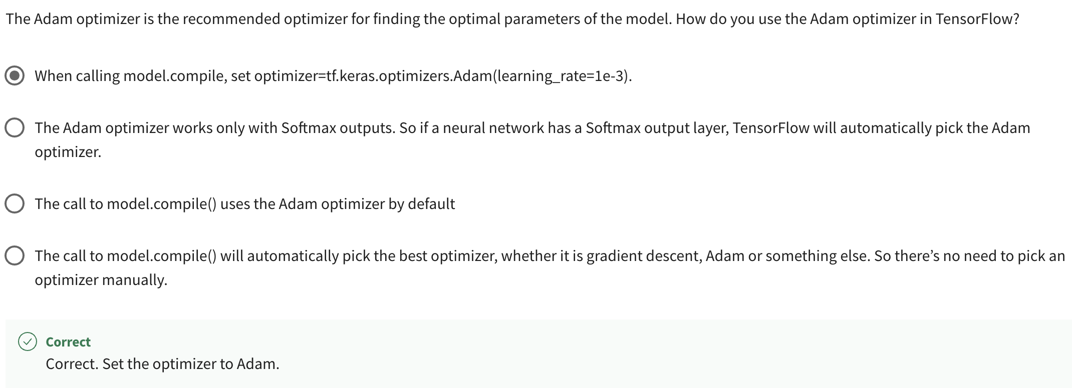

# **Additional Layer Types**

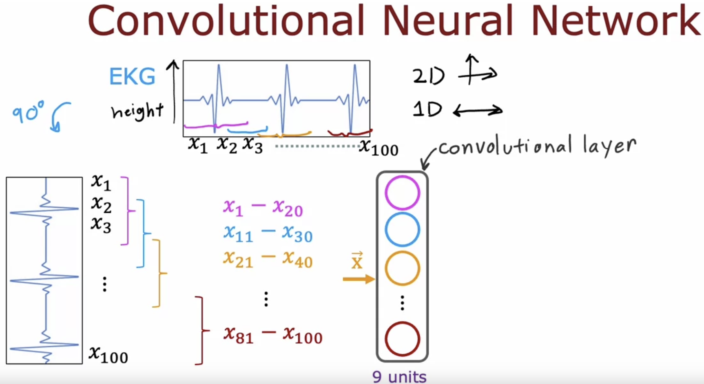  
Layer-1 is known as Convolutional Neural Network because these units in the layer looks at only a limited window of the input.

